Absolute-value norm

Intro

Absolute-value norm adopts the absolute value signature.

It can be only used in 1-dimensional vector space consists of real numbers or complex numbers.

Furthermore, its concept is similar to concept of absolute distance.

Def

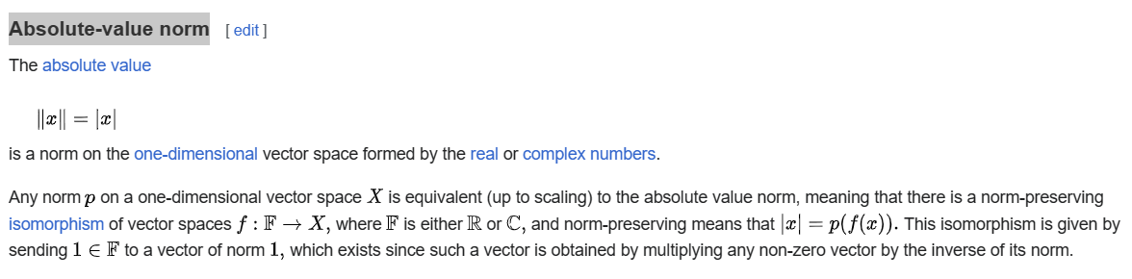

Ref

See absolute-value norm subsection in Examples section in Wiki,

[Norm (mathematics) - Wikipedia](https://en.wikipedia.org/wiki/Norm_(mathematics)#Equivalent_norms)